HTML UNIT 2
Activity 14

Directions: Create a new file Activity 14, then code the webpage shown below. Note there is not an answer key because you are to use the coding knowledge you have previously practiced to code this webpage.
Create This Webpage
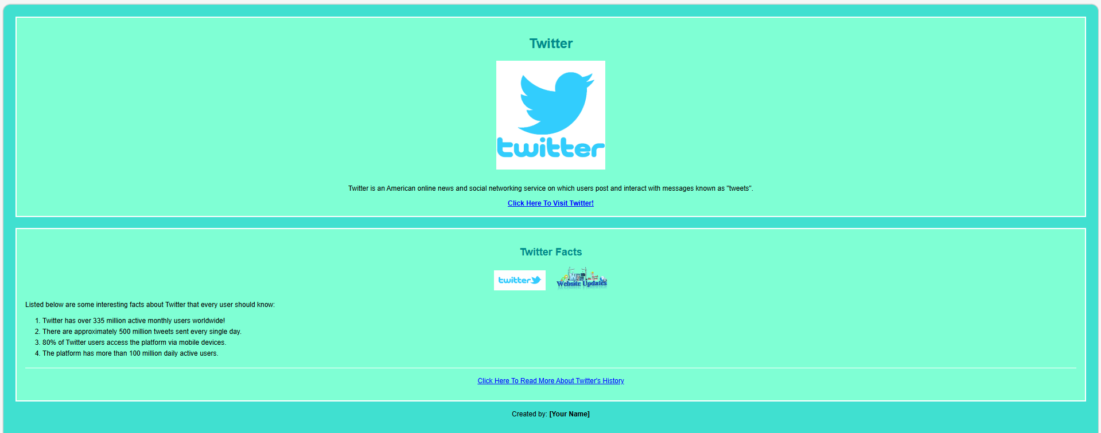
Objective: Images, links and pictures
Insert a link to a website with more facts.
These are 2 separate images!
All images are in your folder.
Insert a link to twitter.

